

Scenario 1 – Student Academic Performance Dashboard:

Program:
import pandas as pd
import seaborn as sns
import matplotlib.pyplot as plt

data = pd.DataFrame({
'Attendance':[75,80,85,90,95,70,88,92],
'Marks':[65,72,78,85,95,60,82,90],
'Department':['CSE','AI','IT','ECE','CSE','AI','IT','ECE']
})

sns.scatterplot(data=data,
x='Attendance',
y='Marks',
hue='Department',
s=120)

plt.title("Student Academic Performance")
plt.xlabel("Attendance (%)")
plt.ylabel("Internal Marks")

plt.savefig("scenario1.png", dpi=300, bbox_inches="tight")
plt.show()

Output:
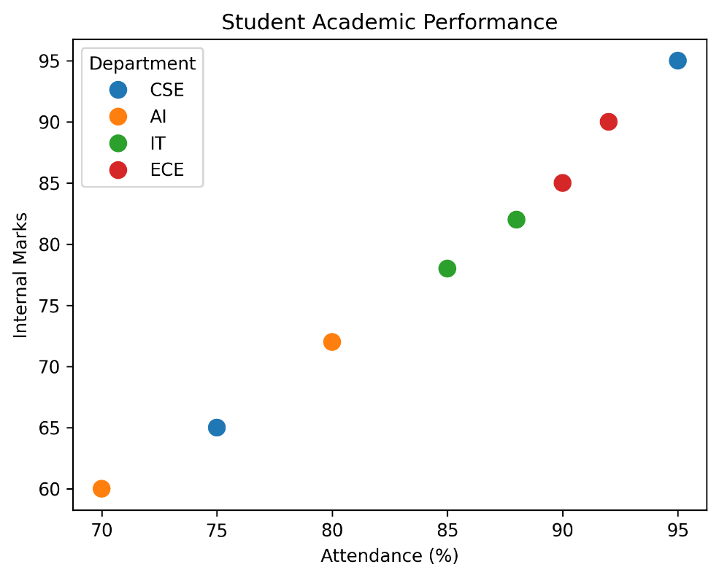

Scenario 2 – Electric Vehicle Market Analysis:

Program:
import pandas as pd
import seaborn as sns
import matplotlib.pyplot as plt

data = pd.DataFrame({
'Battery':[40,50,60,75,90],
'Price':[12,15,18,22,28],
'Range':[250,300,380,450,520],
'Manufacturer':['Tata','MG','Hyundai','Mahindra','BYD']
})

sns.scatterplot(data=data,
x='Battery',
y='Price',
hue='Manufacturer',
size='Range',
sizes=(100,500))

plt.title("Battery Capacity vs Price")
plt.xlabel("Battery Capacity (kWh)")
plt.ylabel("Price (Lakhs)")

plt.savefig("scenario2.png", dpi=300, bbox_inches="tight")
plt.show()

Output:
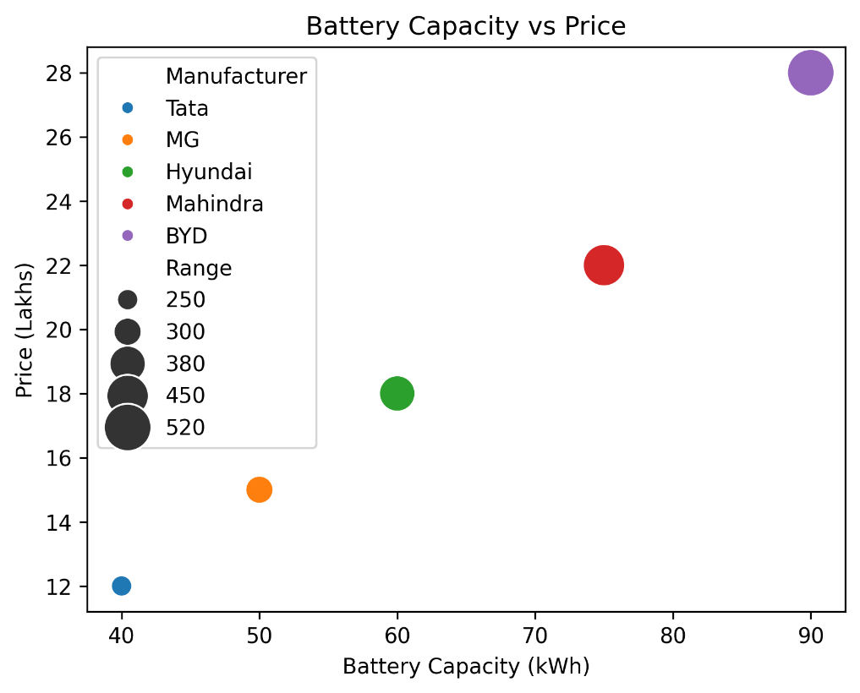

Scenario 3 – Hospital Patient Admission Analysis

Program:

import pandas as pd
import matplotlib.pyplot as plt

data = pd.DataFrame({
'Department':['Cardiology','Neurology','Orthopedics','Pediatrics'],
'Patients':[120,90,140,110],
'Cost':[45000,52000,38000,30000]
})

bars = plt.bar(data['Department'],
data['Patients'],
color=['red','blue','green','orange'])

for bar, cost in zip(bars, data['Cost']):
plt.text(bar.get_x()+bar.get_width()/2,
bar.get_height(),
str(cost),
ha='center')

plt.title("Hospital Admissions")
plt.ylabel("Patients")

plt.savefig("scenario3.png", dpi=300, bbox_inches="tight")
plt.show()

Output:
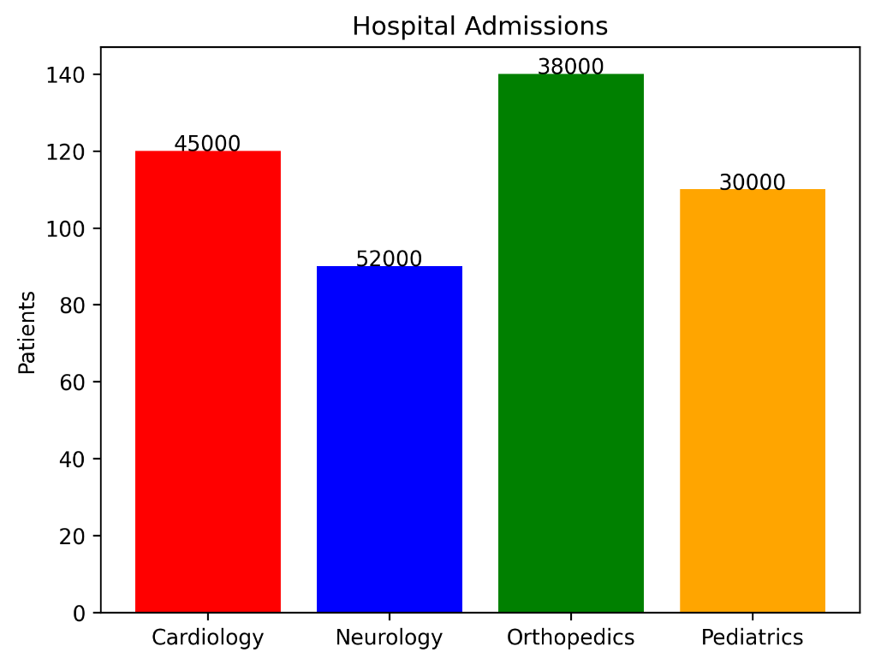

Scenario 4 – Weather Monitoring System:

Program:

import pandas as pd
import seaborn as sns
import matplotlib.pyplot as plt

data = pd.DataFrame({
'Day':[1,2,3,4,5]*3,
'Temperature':[32,33,34,35,34,
28,29,30,31,30,
35,36,37,36,35],
'City':['Chennai']*5 +
['Bangalore']*5 +
['Delhi']*5
})

sns.lineplot(data=data,
x='Day',
y='Temperature',
hue='City',
style='City',
markers=True)

plt.title("Temperature Trends")

plt.savefig("scenario4.png", dpi=300, bbox_inches="tight")
plt.show()

Output:
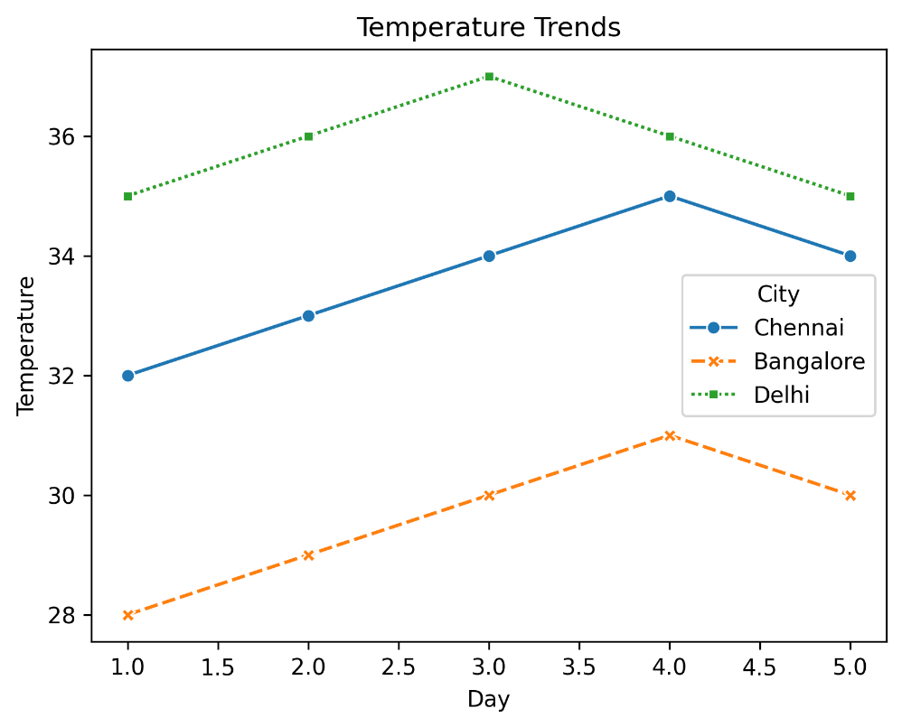

Scenario 5 – Supermarket Sales Analysis

Program:

import pandas as pd
import seaborn as sns
import matplotlib.pyplot as plt

data = pd.DataFrame({
'Category':['Food','Food','Food',
'Drinks','Drinks','Drinks',
'Snacks','Snacks','Snacks'],
'Sales':[120,150,170,90,100,110,80,95,105],
'Branch':['A','B','C']*3
})

sns.barplot(data=data,
x='Category',
y='Sales',
hue='Branch')

plt.title("Sales by Branch")

plt.savefig("scenario5.png", dpi=300, bbox_inches="tight")
plt.show()

Output:

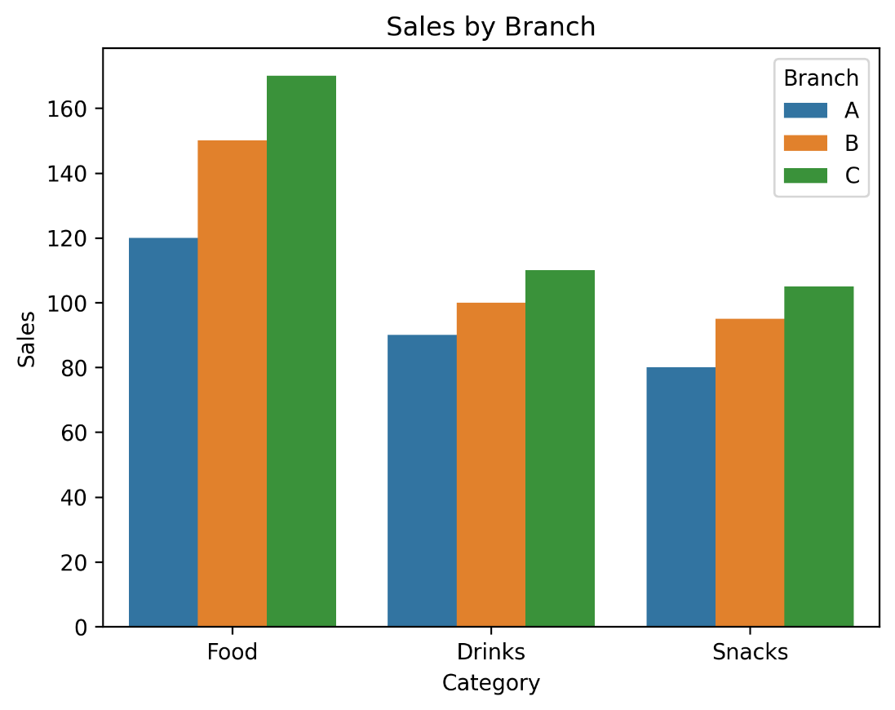

Scenario 6 – Employee Salary Distribution

Program:

import numpy as np
import matplotlib.pyplot as plt

salary = np.random.randint(25000,100000,300)

plt.hist(salary, bins=10)

plt.title("Salary Distribution")
plt.xlabel("Salary")
plt.ylabel("Frequency")

plt.savefig("scenario6.png", dpi=300, bbox_inches="tight")
plt.show()

Output:

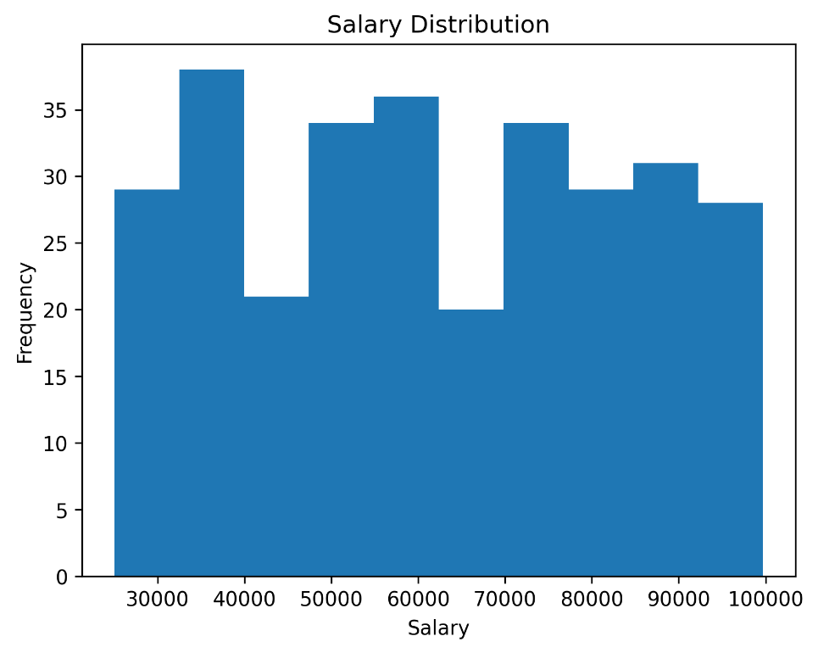

Scenario 7 – Smartphone Market Comparison

Program:

import pandas as pd
import seaborn as sns
import matplotlib.pyplot as plt

data = pd.DataFrame({
'RAM':[4,6,8,12,16],
'Price':[15000,22000,30000,45000,65000],
'Storage':[64,128,128,256,512],
'Processor':[2.0,2.2,2.4,2.8,3.1],
'Brand':['Samsung','Realme','Vivo','OnePlus','Apple']
})

sns.scatterplot(data=data,
x='RAM',
y='Price',
hue='Processor',
size='Storage',
style='Brand',
sizes=(100,500))

plt.title("Smartphone Comparison")

plt.savefig("scenario7.png", dpi=300, bbox_inches="tight")
plt.show()

Output:

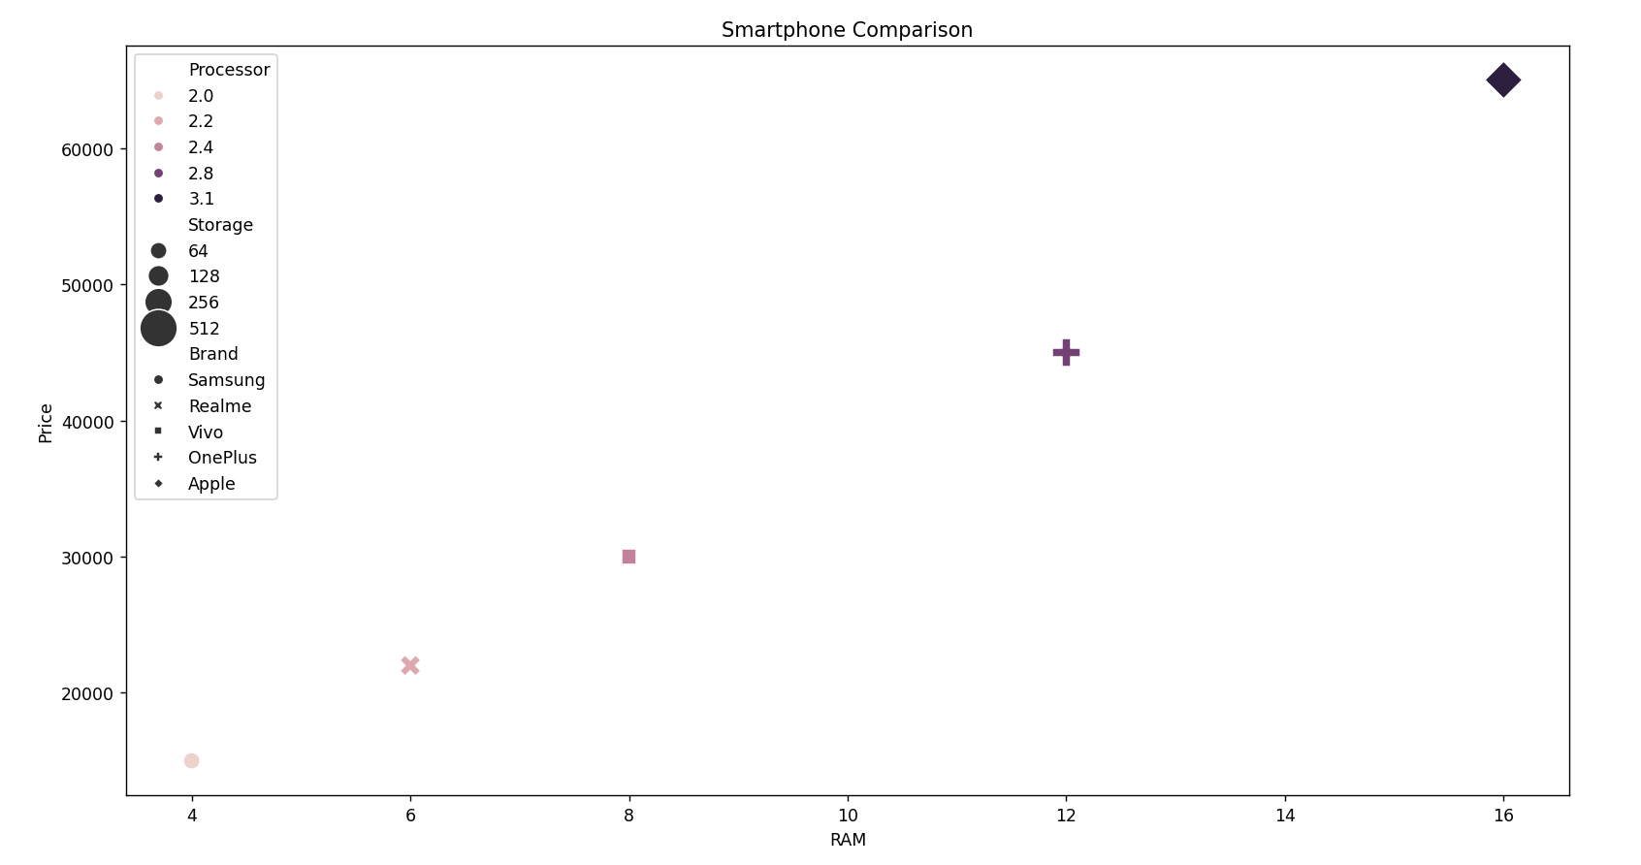

Scenario 8 – Online Movie Rating Analysis
Program:
import pandas as pd
import seaborn as sns
import matplotlib.pyplot as plt
ratings = pd.DataFrame({
'2023':[4.1,4.5,3.9,4.3],
'2024':[4.3,4.7,4.0,4.5],
'2025':[4.4,4.8,4.2,4.6]
},
index=['Action','Comedy','Drama','Sci-Fi'])
sns.heatmap(ratings,
annot=True,
cmap='YlGnBu')
plt.title("Movie Ratings")
plt.savefig("scenario8.png", dpi=300, bbox_inches="tight")
plt.show()

Output:
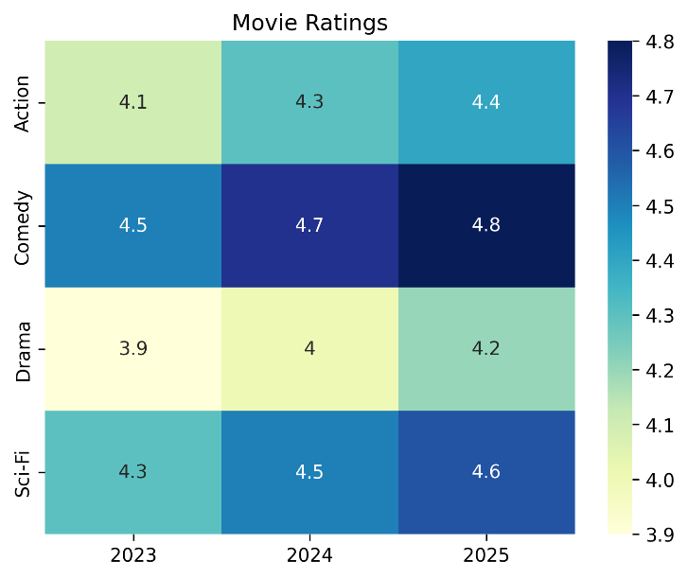

Scenario 9 – COVID-19 State-wise Analysis
Program:

import pandas as pd
import seaborn as sns
import matplotlib.pyplot as plt

data = pd.DataFrame({
'State':['TN','KA','KL','AP','TS'],
'Cases':[1200,1800,900,1500,1100]
})

pivot = data.set_index('State').T

sns.heatmap(pivot,
annot=True,
cmap='Reds')

plt.title("COVID Active Cases")

plt.savefig("scenario9.png", dpi=300, bbox_inches="tight")
plt.show()

Output:

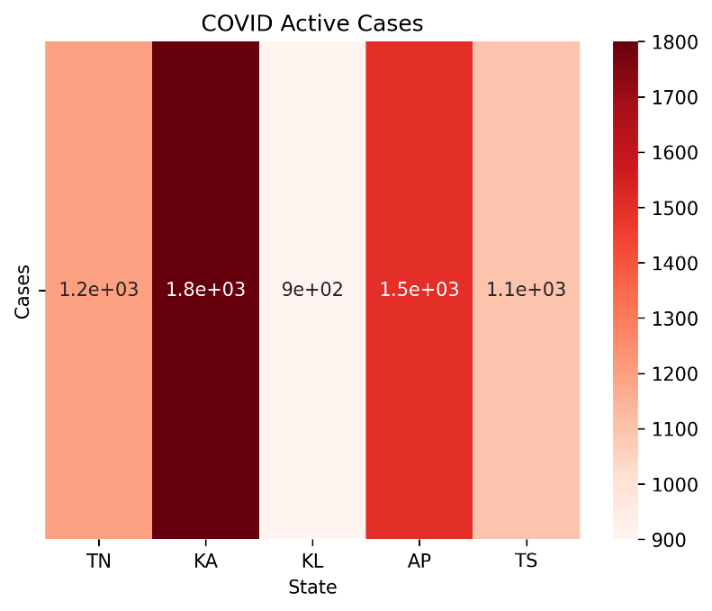

Scenario 10 – Iris Flower Classification
Program:
import seaborn as sns
import matplotlib.pyplot as plt
iris = sns.load_dataset("iris")
sns.scatterplot(data=iris,
x='sepal_length',
y='petal_length',
hue='species',
style='species',
size='sepal_width',
sizes=(30,250))

plt.title("Iris Flower Classification")
plt.savefig("scenario10.png", dpi=300, bbox_inches="tight")
plt.show()

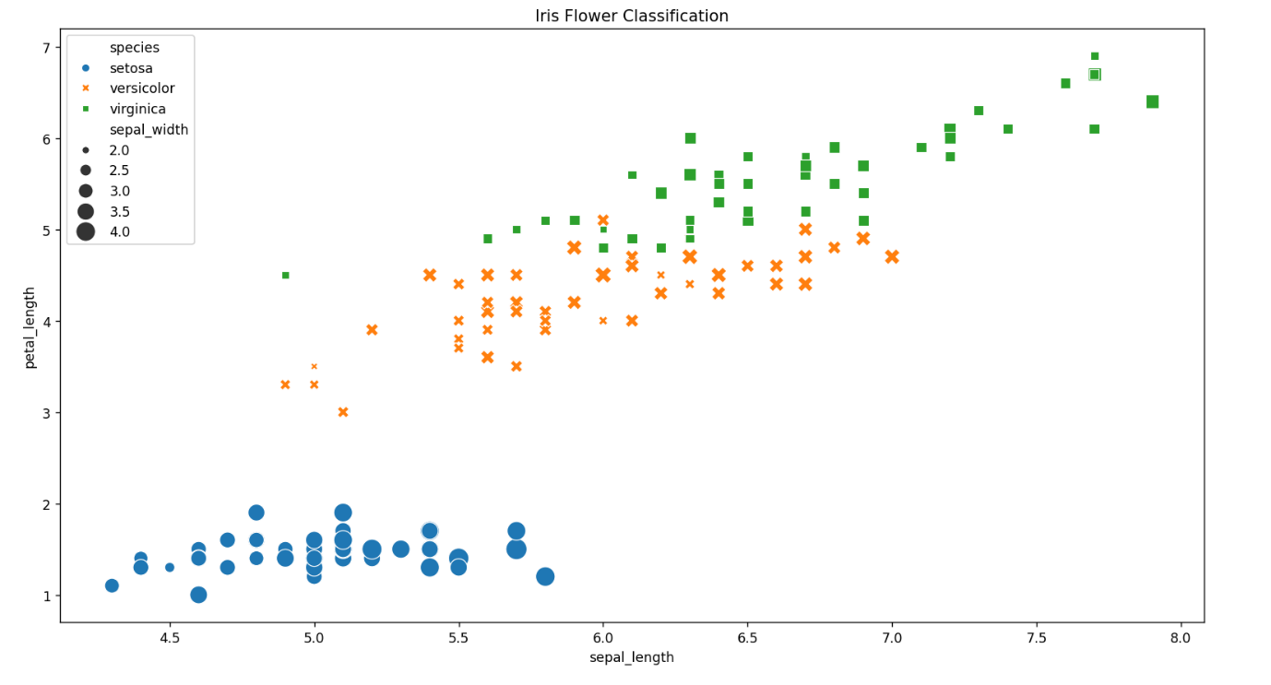
Output:

